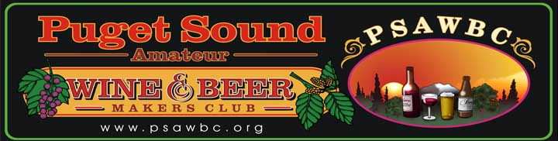

Beer Style: Bitter, E.S.B./Extract

Description: This beer is very tasty. It’s not very nutty, but its got a complex flavor, with a nice balance of hops and caramelly malt flavors. The color is darkish and reddish, really quite beautiful. Yield 5 gallons

Ingredients:
- 1 lb Crystal 60L: 60 min @160 degrees
- 8 lb amber liquid malt extract
- 1 oz Northern Brewer: 60
- 1 oz Yakima Goldings: 30
- 1 oz Yakima Goldings: 15
- WLP-026 (White Labs liquid yeast: Bitter Ale) or similar
- OG: 1.059
- FG” 1.013
- Primary ferment: 14 days
- Seconds ferment: none

Procedure:
Boil 2 gallons and put it in fermenter. Bring 3 more gallons to 160 degrees. Put 1 lb Crystal 60L malt in nylon grainbag, tie off, chuck into pot. Keep flame on until wort gets back to 160, then shut flame off, put the lid on and set timer for 60 minutes. Meanwhile put another pot on the stove and boil a gallon or two of water in it, then turn it off and let it cool with the lid on. Put hops in 3 small grainbags, an ounce in each (not necessary, but it makes it easier). Dump all the malt extract into the pot and stir it up until there are no clumps on the bottom where they could burn. Once it’s all in solution, put the flame back on and heat it up to boiling. Once boiling nicely, skim the foam off the top and throw it away, then pop the Northern Brewers into the pot. Set the timer for 30 minutes. Don’t put the lid back on, keep it at a rolling boil. When the timer goes off, toss one of the Yakima Goldings bags in and set the timer for 15 minutes. When the timer goes off toss the last ounce of Yakima Goldings and set the timer for 15 minutes. When the timer goes off, turn off the flame, put the lid on the pot and cool it to room temp as fast as possible. Put it in the fermenter, top up to 5 gallons with the water boiled earlier, check temp. It needs to be under 80 degrees. Cool it down some more if it’s not there yet. Pitch yeast, fit airlock or blowoff tube. Bottle condition 1-2 weeks.

