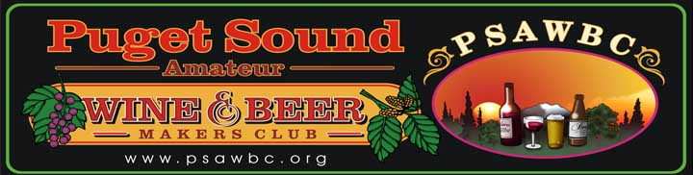

A Few Beer Recipes: makes 5 gallon batches

Nut Brown Ale: a dark brown English ale – 6.5%

- 1 3.5 lb can of hopped light malt extract
- ½ lb black patent malt
- 1 lb crystal malt
- 2 tsp brewing salts
- 2 tsp beer settler
- 5 lbs corn sugar
- 1 ½ cups sugar for priming
- 1 pkg ale yeast
- 5 gallons water

Christmas Ale: A rich amber heavy ale – 5.5%

- 1 3.3 lb can of John Bull Amber hopped malt extract
- 2 cups crystal malt
- 2 tsp brewing salts
- 2 tsp beer settler
- 3 lbs corn sugar
- 1 ½ cups sugar for priming
- 1 pkg beer yeast
- 5 gallons water

Old Glory: a light American summer brew – 4%

- 3 lbs dry malt extract
- 2 oz boiling hops
- 1 cup crystal malt
- 2 ½ tsp brewing salts
- 2 tsp beer settler
- 2 lbs corn sugar
- 1 ½ cups sugar for priming
- 1 pkg beer yeast
- 5 gallons water

Black Beauty: a dark lager beer – 5%

- 5 lbs dark dry malt
- 1 cup black patent malt
- 2 tsp brewing salts
- 2 tsp beer settler
- 1 lb corn sugar
- 1 ½ cups sugar for priming
- 1 pkg beer yeast
- 5 gallons water
- 2 oz Cascade hops

Kopaneck Kreme: a heavy-bodied Rhine brew – 6.5%

- 2 3.5 lb cans of hopped light malt extract
- 2 tsp brewing salts
- ½ package Burton Water Salts
- 2 tsp beer settler
- 2 lbs corn sugar
- 1 ½ cups sugar for priming
- 1 pkg beer yeast
- 5 gallons

Nickerbocker Bock: an old world bock beer – 7%

- 1 3.3 lb can of John Bull hopped dark malt extract
- 1 lb crystal malt
- 1 oz finishing hops
- 2 tsp brewing salts
- 2 tsp beer settler
- 3 lbs corn sugar
- 1 ½ cups sugar for priming
- 1 pkg beer yeast
- 5 gallons water

Steam Beer: San Francisco steam beer – 5.5%

- 1 3.5lb can of Munton and Fison Amber hopped malt syrup
- 1 lb crystal malt
- ½ package Burton Water Salts
- 1 oz finishing hops
- 2 tsp brewing salts
- 2 tsp beer settler
- 3 lbs corn sugar
- 1 ½ cups sugar for priming
- 1 pkg beer yeast
- 5 gallons water

Einbacker Alt: an all-malt beer 6.5%

- 2 3.5-lb cans light malt syrup hop flavored and unhopped
- ½ lb black patent malt
- 1 oz finishing hops
- 2 tsp beer settler
- 1 pkg beer yeast
- 5 gallons water

Canadian Light: 6%

- 1 2.5-lb can hopped light malt syrup
- 2 ½ tsp brewing salts
- 2 tsp beer settler
- 4 lbs corn sugar
- 1 ½ cups sugar for priming
- 1 pkg beer yeast
- 5 gallons water

The Flow of Beer:
Tips: to “rack” means to siphon or transfer from one container to another. Make sure to thoroughly sanitize every piece of equipment that comes in contact with your beer.

In large container mix 1-2 gallons water and malt syrup. Add hops when using unhopped malt (crystal and black patent). Boil 1 hour, then cool. Add water to make 5 gallons, corn sugar, brewing salts, beer yeast. Put in primary fermentor. After 5 days, transfer to carboy and add beer settler. Top with airlock. Keep water in airlock and airlock on carboy at all times. Ferment for 10 to 20 days. When beer is clear, rack and prime. Add 1 ½ cups sugar. Transfer beer to sterilized bottles. Top with sterilized caps. Age beer one month. Enjoy!

